To: The PATH School
From: Alicia Hervey, Head of School
Date: June 24, 2022
Subject: Additional/Specific Guidance

In light of the COVID-19 pandemic, The PATH School has committed to ensuring that all scholars are safe while in school. This plan is established as a starting point to protect the school community against all health-related hazards and will be monitored and revised as needed and as new information is provided by trusted institutions, such as the Center for Disease Control, Indiana State Department of Health, Marion County Health Department, executive orders from the governor, and the Indiana Department of Education. The PATH School will continue to coordinate its efforts with all of the aforementioned institutions.

The following outlines new measures in place for the 2022-2023 school year.

- The 2022-2023 school calendar remains the same.
- All CDC, EPA, and OSHA cleaning and disinfection procedures will be followed, including, but not limited to, all buildings, surfaces, equipment and playground structures.
  - Rooms will be sprayed weekly to ensure the maintenance of healthy facilities.
- Safety drills will have the following modifications in place:
  - Fire Drills will be “slowed down” to maintain social distancing. Drills should be clearly announced so scholars and staff are aware of the drill. One-way paths for evacuation will be established.
  - Tornado Drills will allow for social distancing.
  - Lock-Down Drills will allow for social distancing.
  - Bus Evacuation Drills will be conducted at the end of the route. Scholars and staff will be required to wear face masks while on the bus, even during a drill.
- Drop off/Pick Up
  - Masks will be made available to scholars upon entry at every door, and scholars and staff may wear masks while in the building.
  - Children’s sized masks will be available at each entry.
  - Visitors may wear masks while in the building.
- Physical Distancing
  - Classes
    - Technology, textbooks, and other materials will be assigned to scholars.
    - Scholars will rotate to classes and desks will be cleaned between classes.
    - Bathroom breaks will be scheduled to increase physical distancing.
  - Specials
    - Physical Education will consist of “minimal contact” activities.
      - All materials will be sanitized daily.
  - Lunch will be served in the cafeteria with social distancing.
    - Tables and seats will be assigned for lunch.
  - Scholars may wear face coverings during all assemblies and field trips
  - Bus Procedures
    - All scholars, drivers, and monitors riding the bus may wear face coverings.
    - Scholars will have assigned seats on the bus.
    - Sanitation measures will be in place after final drop offs to and from school.
    - Eating or drinking on the bus is not permitted.
  - Recess periods will be shared by grade levels.
  - Space between scholars will be increased as much as the classroom and furniture allows.
    - Scholars will have assigned seating.
      - Seating charts will be maintained by all teachers for exposure tracing.
- Shared spaces, such as special education classrooms, ELL classrooms, the nurse’s clinic, behavioral, counseling, brain labs, and speech offices, will be sanitized daily.
      - Seating will adhere to physical distancing guidelines.
  - Whole staff meetings will be held in spaces that allow for physical distancing.
  - Staff will sanitize shared workstations and breakrooms daily.
    - Sanitizer will be provided in shared spaces.
- Nutrition Service
  - Breakfast will be served in the classroom daily for middle school scholars. After eating, scholars will sanitize their work eating/work area.
  - Elementary scholars will retrieve their breakfast from the cafeteria upon entry to school and will return to their classrooms to eat. Kindergarten and 1st grade scholars will eat in the cafeteria with physical distancing.
  - Scholars will use hand sanitizer or wash hands before and after meals.
  - Food sharing of is prohibited.
- Water fountains are not to be used with a person’s mouth.
  - Scholars will be provided water bottles to be used at water stations.
  - Scholars are expected to use their water bottles for water.
- Touchless hand sanitizer stations will be placed at the entrance to the school, all entrances into the school from recess and in other locations throughout the school.
  - Scholars and staff are expected to use these stations upon entry to the school building.
- Teachers will limit the number of items that go between school and home as much as possible.
- All visitor sign-in sheets will be maintained and documented to assist with exposure tracing.
- All in-person staff meetings will have sign-in sheets to document attendees.
- Visitors may wear facial coverings whenever in the building.
- Staff and Scholar Health Monitoring and Education
  - The school will track reasons for scholar and staff absences as allowable.
    - If a parent tells the school that a scholar is ill, the school will ask the parent if the student is exhibiting symptoms of COVID-19.
    - If a staff member calls in sick or appears ill, the school will ask if the person is experiencing any COVID-19 symptoms.
    - If a person is visibly ill, the school may make additional inquiries and may exclude the person from school property.
  - If a person has recently come in contact with a person with a suspected or confirmed case of COVID-19, has someone in their home being tested for COVID-19, or has recently traveled from somewhere considered a “hot spot” by the CDC, the school may exclude the person from the school building and recommend they self-quarantine for 5 calendar days.
  - Staff will receive training from the school nurse prior to the start of the school year on recognizing COVID-19 related symptoms in oneself and others and how to respond based on the school’s Safety Plan.
    - Scholars and staff will be excluded from school/work if they test positive for COVID-19 or exhibit symptoms associated with COVID-19 that are otherwise not explained.
      - Those excluded from school who have not received a test proving or disproving the presence of COVID-19 may return to school if the following three conditions are met:
        - They have not had a fever for at least 72 hours; and
        - Other symptoms have improved; and
        - At least 5 calendar days have passed since the symptoms first appeared.
      - Scholars and staff who have been tested for COVID-19 may return to school if the following conditions are met:
        - The individual no longer has a fever (without the use of a fever reducing medication); and
        - Other symptoms have improved; and
        - At least 5 calendar days have passed since symptoms first appeared; or
        - The person has received two negative tests at least 24 hours apart.
      - Scholars and staff who are asymptomatic and test positive for COVID-19 may return when they have gone 10 calendar days without symptoms and have been released by a healthcare provider.
    - All positive cases of COVID-19 will be reported to the Marion County Health Department and the Indiana Department of Education for additional guidance.
      - A separate room will be provided for staff and scholars who may have COVID-19 while waiting for pick-up. The room will be disinfected frequently and restricted to only authorized staff and scholars.
      - As soon as the school is aware of a confirmed case of COVID-19 in the building, the custodial staff will be immediately informed. When possible, based on student and staff presence, the custodial staff will wait 24 hours or as long as possible prior to disinfecting. When waiting is not possible, such as when school is in session, the cleaning will occur immediately with all custodians wearing appropriate PPE.
  - Staff may wear a facial covering that covers the nose and mouth appropriately.
    - All staff involved with health, custodial, and/or food related services may wear facial coverings that cover the nose and mouth appropriately.
    - All non-classroom teachers, such as administration, special education, specials, etc., may wear facial coverings that cover the nose and mouth appropriately when working with scholars and outside their offices.
  - Scholars may wear facial coverings that cover the nose and mouth appropriately while in school daily.
  - Frequent handwashing and sanitizing is encouraged, especially at the following times:
    - Start of the school day
    - Before and after eating
    - After using the restroom
    - After blowing nose, coughing, or sneezing
    - Before and after using shared equipment
    - After recess
  - Scholars health plans will be created and implemented as needed with guidance from the scholar’s family doctor, parents, director of special education and the school nurse.
  - The school nurse will provide lessons to scholars on social distancing, hand washing, and other general health-related topics that stop the spread of COVID-19 at the beginning of the year and on an ongoing basis as necessary
    - Information on self-screening will go home to parents prior to the start of the school year.
    - When/If the opportunity arises, The PATH School will work with its nursing partner, Shalom Health, to provide diagnostic screening and testing to scholars and potentially provide vaccinations and/or booster shots to the school community.

Mask Wearing
When selecting a mask, there are many choices. Here are some do’s and don’ts.

DO choose masks that
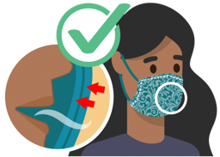
Have two or more layers of washable, breathable fabric
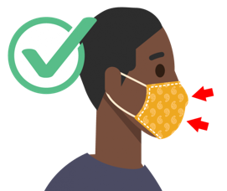
Completely cover your nose and mouth
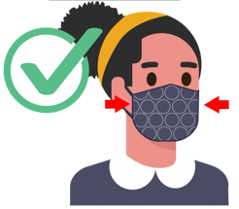
Fit snugly against the sides of your face and don’t have gaps
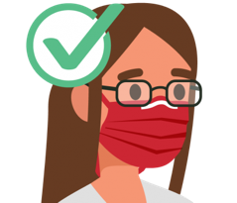
Have a nose wire to prevent air from leaking out of the top of the mask
DO NOT choose masks that
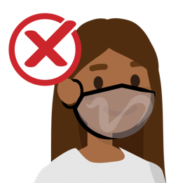
Are made of fabric that makes it hard to breathe, for example, vinyl
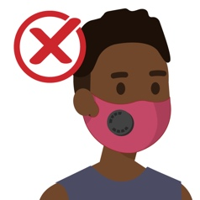
Have exhalation valves or vents which allow virus particles to escape
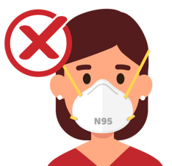
Are prioritized for healthcare workers (e.g., N95 respirators labeled as “surgical” or “medical”)
Do wear a mask that
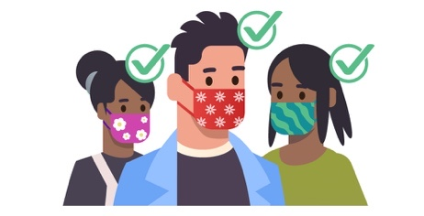
- Covers your nose and mouth and secure it under your chin.
- Fits snugly against the sides of your face.

