Family Newsletter
Friday, October 28, 2022
The PATH School
Message from the Executive Director  I want to thank each of you for coming to support your scholars during Scholar-Led Conferences. This was one of the best turnouts we’ve had since our arrival. Your young people are working hard, and since your conferences, they have been working even harder. Please continue to look for their homework and ensure they’re getting it done, and let’s make sure they are reading at least 20 minutes per day.  This year, we are working extremely hard to help scholars recover the skills they may have missed during the COVID-19 pandemic. Each week, they are taking assessments to help us gauge where they are as it relates to ILEARN. These assessments are not easy, but with targeted instruction and focus, we are confident your scholars will get better. As a school, we MUST improve our ILEARN and IREAD-3 scores, and we’re working hard to do just that. If you’d like to know more about what we’re doing, please don’t hesitate to contact your child’s teacher.  As always, thank you for trusting us with your child’s education. We take this work very seriously.  In service,  Alicia Hervey  Executive Director |  | Halloween Fun!  Monday is the big day! On Monday, October 31, 2022, we will have Halloween celebrations throughout the building. Your scholars are welcome to wear their costumes, but they may NOT wear masks. Please make sure all costumes are appropriate for school. If scholars are wearing inappropriate costumes, we will call you to pick them up.  We will still be learning on Monday; so, let’s make sure they’re prepared to learn while having a little fun.
A Trip to the Indiana State Museum  (1st Grade)  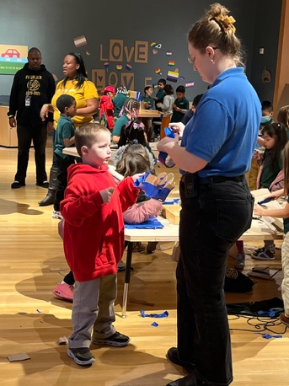 | Family Engagement News  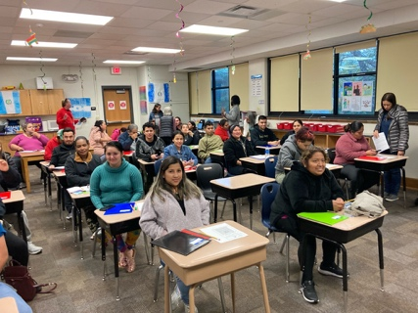  Congratulations to all of you who are taking our English class. Mr. Bolden and Ms. Crespo are enjoying the class and are so glad to have each of you in it! | Looking ahead  - November 8, 2022, Family Engagement meeting  - November 15, 2022, Board of Directors meeting (Media center)  - November 21, 2022, Fall Celebration of Learning  - November 23-25, 2022, Thanksgiving Holiday  - November 28, 2022, Professional Development (No school for scholars)

