Family Newsletter
Friday, December 2, 2022, 2022
The PATH School
Message from the Executive Director  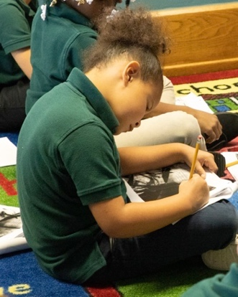  I hope each of you enjoyed a rest-filled holiday with your friends and family. The Thanksgiving holiday is always a great reminder of all of the things we have to be grateful for, and I’m so grateful for the young people you choose to allow us to educate. We serve an amazing group of scholars, and that’s a testament to all that you do at home.  Over the next few weeks, we will continue to push our academic work. Some of you have received progress reports to help you see where your scholar needs to improve. If you’ve not gotten an academic update, please reach out to your child’s teacher.  Finally, while we won’t host a musical concert for the holidays this year, we are planning a huge event that we believe will be fun for all. Please be on the lookout for more information about our Holiday Celebration.  In service,  Alicia Hervey  Executive Director | HOWEWORK  We all know how important it is for young people to practice, and that’s the purpose of homework. Please help us help your scholars by making sure they are completing their homework each week. Let’s make sure they are studying their spelling words, and let’s make sure we’ve set aside some time for them to read daily. If you need books for your child, please let your child’s teacher know, and we will make sure we send those home with him/her.
Learning at The PATH School  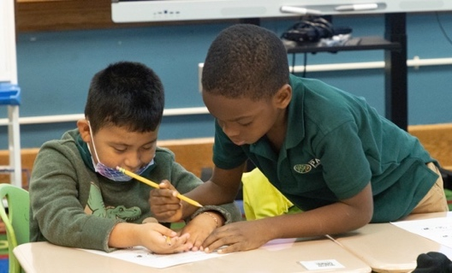  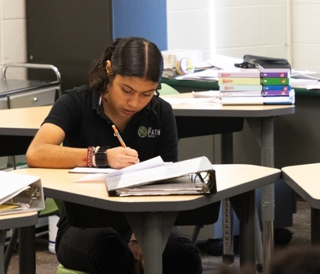 | Looking ahead  - December 21-January 3, Winter Break

